Woodnewton – a learning community
Rowlett Road CORBY Northants NN17 2NU Tel: 01536 265173

24 May 2019

Dear Parent/Carer

Class Photographs

On 8th May every class in the school had photographs taken. Children were photographed in friendship groups within their class. We hope you like the results, which are on display in the main office. Due to the rising costs of class photographs, we will be reviewing which year groups will be photographed next year. Our decision will be based on the uptake of orders placed.

Nurture Group Information Evening
Also on 8th May, Esther Gray, the Nurture Group Leader invited schools from the whole area to a meeting where she outlined how the Nurture Group worked and more importantly how to access its services. Eight schools attended and hopefully this meeting proved to be very useful to them.

Y6 SATS
As parents of Y6 children will be only too aware, this year’s SATS took place between 13th and 16th May. To help to settle the children, they were invited to a free daily breakfast club, which was extremely well attended. They were then tested throughout the week in English and Maths and we await the results which will be announced towards the end of the Summer Term. Good luck to them all.

As a reward for ‘surviving’ the week, the whole year group visited the Savoy cinema on Friday 17th to see Pokemon Detective Pikachu. It was a lovely way to finish the week and the children behaved brilliantly. They were great ambassadors for our Academy.

Discos
This week, all year groups except Y6 were invited to a disco. For a small fee, they were provided with a drink, a snack and the services of a DJ. These were very well attended and a good time was had by all.

Y6 will be having their special leaving event later in the year.

FS1 News!
Exciting events in FS1. The eggs hatched and eleven chicks were returned to the farm. We now have caterpillars in various stages of development. These will hopefully become butterflies. Watch this space.

Amidst all this excitement a group of children visited George Blackhall Court and sang along with the residents. It was a lovely event enjoyed by young and old alike. Well done.

Hot News
On 6th June Sarah Dempster of FS1 fame will become Mrs Gaziano at a wedding ceremony in Ibiza. We wish them both health and happiness for their future together.

From the Principal
A reminder:- Unless there is a reason, could parents and children leave school through the gates and not through the main office at the end of the day thank you.

Sun Cream
As we enter the Summer Term and hopefully experience some hot weather, could you please ensure that your child wears a sun hat and has sun cream labelled and left in the Academy. Could you also show your child how to apply the cream. Thank you.

School Comms
On our return further information will be sent in regards to our new communications system. If you still have not returned your letter with your mobile number and email address could you please return after the term break. Should you need another copy of this please go to the main office. We have only had a return rate of 60%. All our communications will be moving to this electronic format. Thank you in anticipation of your support.

And finally…

School re-opens on Monday 3rd June. Enjoy the break. I hope you all have a safe week and may the sun shine

Yours sincerely
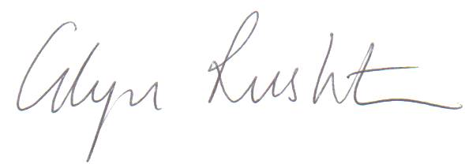
Glyn Rushton - Principal

