Woodnewton – a learning community
Rowlett Road CORBY Northants NN17 2NU Tel: 01536 265173

25 October 2019

Dear Parent/Carer

Knife Crime Workshop
As part of the ongoing theme, ‘Helping Children Learn to keep themselves safe’, there was a ‘Knife Crime Workshop’ for children in Year 5 on 18 September, when the Police visited the Academy and worked with the children on this very important issue. This provided a valuable insight and awareness and was very thought provoking. Also as part of this programme, we have planned ‘Hate Crime Workshops’ where we intend to look at our similarities and celebrate our differences.
Protecting our Planet
Representatives from Corby Borough Council visited school and talked to the children throughout the Academy about how we can begin to protect and improve our environment and do our bit to help the planet. We need to educate the next generation to avoid a catastrophe.

Parent Consultations – Year 6
These took place on 3, 10, 17 and 24 October and provided the opportunity for parents and staff to discuss expectations for their children. Teachers were able to report on how the children had settled into their new classes and also to outline areas in which parents could support their child’s learning. These were invaluable meetings and set the tone for what is a very important year as the children head towards the secondary phase of their education.

Reminder for Year 6 - parents must apply for secondary school places by 31 October.

Pirate Day – Year 4
Year 4 held a ‘Pirate Day’ this week as the exit point for their topic ‘Blue Abyss’. The children dressed as pirates and took part in various pirate themed activities. These included boat making, musical activities including singing and writing, a pirate investigation, which used maths skills to find the ‘Pirate Thief’ and finally created their own map with clues to find treasure. A great day was had by all.

Discos
During the final week of term year groups 1-6 have enjoyed after school discos. The entrance fee helped to provide funds for a DJ and also a drink and snack. These were lively and enjoyable events and provided a fitting end to a long term.

Next Term
This begins on Tuesday 5 November and we would like to give advanced notice of events during this week. Flu vaccines will be administered to all year groups from Foundation 2 to Year 6. There will be Parent Consultation meetings on 6 and 7 November for children in Y4BM. On 7 November at 10.00 am and 6.00 pm there will be a tour around the Foundation Stage 2 area for anyone interested whose children will start September 2020.

Academy individual photos will be taken on 15 November – letter to follow.
Poppies and merchandise will be on sale in the Academy to support forces’ charities and commemorate Armistice Day.

From 5 November all Academy correspondence will be via the School Gateway App – please ensure that you have downloaded it by this date to receive all our communications. Thank you in advance of your continued support.

Car Parking
An old chestnut!! May we request more ‘CONSIDERATE’ parking by parents collecting and dropping off children. We receive endless complaints from neighbours and other parents regarding this issue and as we head into the darkness of winter, this can be a safety issue for all of our children. We appreciate that the majority of our parents park very responsibility. We would like the majority to become ALL!

And Finally ….
Have a lovely week with your children – avoid things that go bump in the night – survive Halloween and return your children refreshed and to sparkle on bonfire night!

Yours sincerely
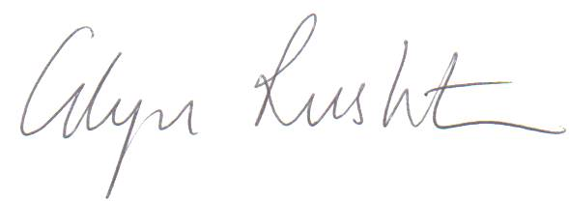
Glyn Rushton – Principal

