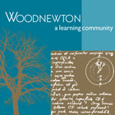

W/C 22.06.2020: Learning Project – Transport
Year 4
Weekly Reading Tasks | Weekly Spelling Tasks
Monday- https://www.bbc.co.uk/bitesize/clips/z4fvr82  Can you invent a car of the future? Can you produce an advert to sell your car? Describe the special features and use persuasive language to attract new customer. | Monday- Create an A-Z list of transport related words. How quickly can they complete this?
Tuesday – Read ‘Downhill Racers’ using Oxford Owl. Encourage your child to answer the questions at the back of the book in full sentences. | Tuesday - Practise spelling these words: invention, injection, action, hesitation, completion. Can your child think of other suffixes to add to the root words to alter the meanings e.g. invent+ing= inventing, invent+ed= invented.
Wednesday https://www.bbc.co.uk/bitesize/clips/z4fvr82Watch the clip about Victorian transport. Can you write five questions to go alongside the clip. | Wednesday – Choose 5 Common Exception words from the curriculum spelling list (see below) and write them into sentences about travelling.
Thursday - Ask your child to read the poem Look at the Train! They can write their own poem about a mode of transport using onomatopoeia (when a word describes a sound and mimics the sound of the object/action) to evoke sounds and rhythm. | Thursday- Play ‘Spelling tiles' to practise spelling of  homophones and near homophones (3)
Friday - Read about the Great Western Railway company. Can you write five facts about the history of the company?  file:///N:/STEAM_Education_Pack_2___The_Story_of_the_GWR.pdf | Friday - Play Spooky Spellings to recap words from the Year 4 spelling list.
Weekly Writing Tasks | Weekly Maths Tasks
Monday - Watch the animated story Ruckus from The Literacy Shed.  Use pictures and sentences to retell the story in chronological order as a comic strip, showing 6 scenes from the film. Include some thought bubbles to show what the characters might be thinking. | Monday- Use Daily ten to practise rounding, doubles and halves, multiplication and division.
Tuesday- Using the comic strip from yesterday’s activity, write some dialogue to show what the brothers might be saying to each other. | Tuesday- Data collection - Ask your child to survey the transport which goes past your home. Tally the different vehicles/vehicle colours and then create a bar chart or pictogram. Write statements about the data e.g. Silver was the most popular colour car. There were 3 more taxis than bikes etc.
Wednesday- Create a ‘Wanted’ poster, giving detailed descriptions of the brothers and why they are wanted. Will you include a reward for anyone who finds them? | Wednesday- Play Hit the Button - focus on number bonds, halves, doubles and times tables.
Thursday- Imagine that your ‘Wanted’ poster has been successful and the jewel thieves have now been caught. Write a newspaper report about the theft of the ruby. Include as much detail as possible. Remember to use the 5 Ws – when, where, what, who & why. Finish the report with what has happened to the thieves now they have been caught. | Thursday- Use the interactive teaching clock to practise reading the time on analogue and digital clocks.
Friday - Plan and write a journey story. Where is the main character going and why? What happens on his/her journey? How does the main character overcome this? | Friday-Have a go at some of these activities on time.  https://www.bbc.co.uk/bitesize/topics/zkfycdm/articles/zcrmqty

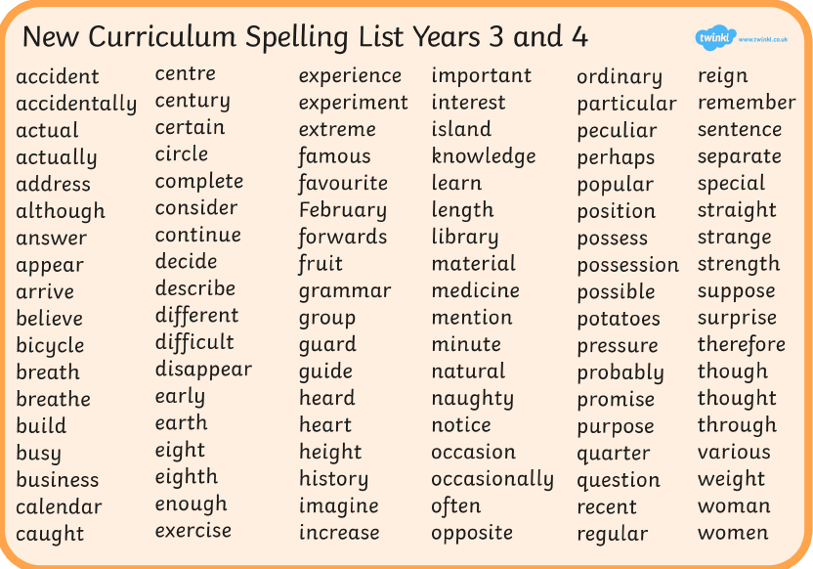

Learning Project - to be done throughout the week
The project this week aims to provide opportunities for your child to learn more about transport. Learning may focus on modes of transport, transport in the past, the science behind transport, road safety and how to be safe around water.

- Let’s Talk Transport -Talk as a family about transport in your life. Talk about how you get to school and work. Do you get your food delivered? Does anyone in the family operate a mode of transport? Is it their job? Discuss the first family car owned. Ask your child to mind map all of the ways your family relies on transport and then to imagine a life without it.

- Obstacle Course - Ask your child to find any toy transport (cars, trains, etc) they may have at home, then they can design an obstacle course for their vehicle to travel around. This could be on a track or floor involving ramps inside or in the garden.

- Transport Around the World - Ask your child to find out all the different methods of travel in Britain and compare these to different methods in other countries, e.g. rickshaws, gondolas etc.

- Aeroplane flights - Get each family member to make a paper aeroplane and throw each one in turn and see whose travels the furthest. Ask your child to measure the lengths of the distance travelled and record these on a bar chart.

- Transport Inventors - Ask your child to find out about famous transport inventors such as Henry Ford and The Wright Brothers. Create fact files about these inventors. Can your child draw sketches of different modes of transport then and now. Can they place different modes of transport on a timeline using their invention date?

P.S.H.E. & Wellbeing
- Mindfulness challenge
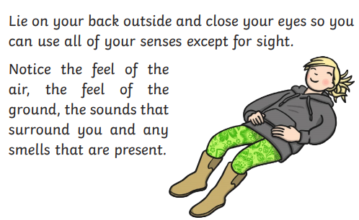

- Brain Break – I can fly
Pretend you can fly like an aeroplane, a bee, a kite, a butterfly, an eagle for 10 seconds each.

- Draw a strengths ‘Family tree’, either for your family, a group of your friends, your class or your school. Think about how these character strengths you all have can help you overcome challenges together.

- Cosmic Yoga – The Bye Bye Boat Cosmic Kids Yoga Disco – Hot air balloon

STEM Learning Opportunities #sciencefromhome
Brilliant Boats
● Using just 1 sheet of paper and some paperclips design a raft that will hold as many coins or marbles as possible. You can download the activity card here to help you.
Additional learning resources parents may wish to engage with
- BBC Bitesize - Lots of videos and learning opportunities for all subjects.
- Classroom Secrets Learning Packs - Reading, writing and maths activities for different ages.
- Twinkl - Click on the link and sign up using your email address and creating a password. Use the offer code UKTWINKLHELPS.
- White Rose Maths online maths lessons. Watch a lesson video and complete the worksheet (can be downloaded and completed digitally).
- Times Table Rockstars and Numbots. Your child can access both of these programmes with their school logins. On Times Table Rockstars, children should aim to play Soundcheck for 20 minutes daily.
- IXL online. There are interactive games to play and guides for parents.
- P.E. with Joe Daily P.E sessions with Joe Wicks accessed through YouTube.
- Supermovers Movements to music/raps focussing on different curriculum areas

