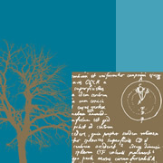 PSHE / WELL-BEING ACTIVITIES FOR YEAR 3.
Positivity | Each night discuss with your child these 3 things:-  - I am grateful for……….  - What would make tomorrow great……..  - Tell me the 3 best things that happened today….
Friendship | Task your child with making a card for a friend. They could draw a picture to decorate the front of the card, paint or stick anything you have available to make a picture. Inside they could tell their friend all the things that they find special about them.
Relationships | Encourage your child to draw a picture of all the people that are important to them, a bit like a class photo. Draw a decorative frame around the outside. Maybe they could display it somewhere to remind themselves of the people they are lucky to have in their lives.
Health | Work together to create an obstacle course or circuit, inside or outside. Time each other completing the course. Can you do it faster another day?
Mindfulness | Share this story with your child The Huge Bag of Worries by Virginia Ironside.  https://www.youtube.com/watch?v=CDrnuPj7xfs  Is there anything worrying them they would like to discuss.

