Learning Project Summer 2, week commencing 06.07.20 – Holidays.

Year 3

Weekly Reading Tasks | Weekly Writing Tasks
Monday - Encourage your child to read in the shade outside or recreate laying on a beach or in a park. | Monday – ​ ​Encourage your child to write a recount of a favourite holiday, a school trip or a relaxing day at home. Think about the correct order that events happened during the day.
Tuesday – ​ Explore this site https://www.bbc.co.uk/teach/school-radio/audio-stories/zh3t2sg  The stories are grouped by topic and then by Key Stage. Use the space they created yesterday to listen to an audio story. | Tuesday – Ask your child to write a list of things they would need to pack if they were going somewhere hot or cold. Would the list be different?
Wednesday - ​ Try researching and reading online together about a place you have not been too before. It could be a country, a town or a tourist attraction. | Wednesday – ​ Imagine someone new has joined Woodnewton a learning community and they are new to the area. Task your child with creating a leaflet of all the things you can do in Corby. Think about how you could present this, could you use headings and subheadings? Would you include pictures or diagrams?
Thursday - ​ Can your child make a holiday themed bookmark? Over the summer break, encourage them to write down, on the back of the bookmark, all the books they have read. As a challenge set them a given number of books you would have liked them to read by September. | Thursday - ​ Ask your child to write a story using this picture as a stimulus.  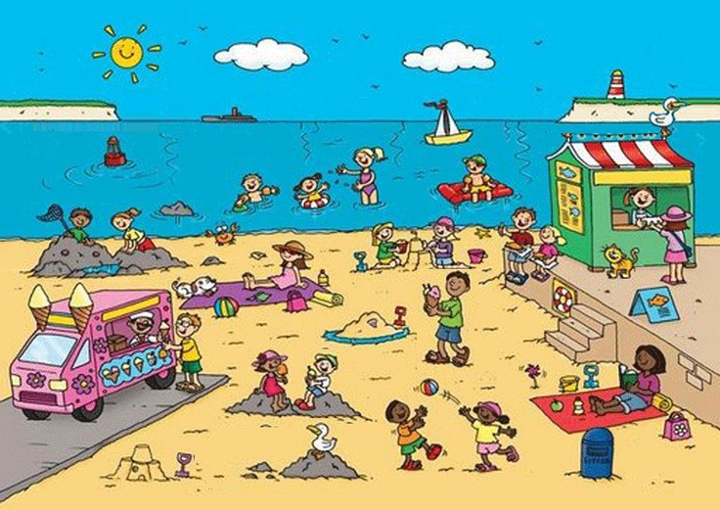
Friday - Encourage your child to read for enjoyment. https://home.oxfordowl.co.uk/ Can your child design an alternative book cover for their chosen book? | Friday – Reread your story from yesterday and edit it. Check your spelling, punctuation and grammar. Are there are parts you could improve?
Weekly Spelling Tasks | Weekly Maths Tasks
Monday - ​ Task your child with creating their very own holiday themed word bank e.g. beach, caravan, sun cream. They can refer to this for some of their writing tasks. | Monday - ​​​On paper and ask your child to show everything they know about Money.​ This could be pictures, diagrams, explanations, methods etc.
Tuesday - Practise spelling 5 Common Exception words. | Tuesday – Write the cost of different items (in pounds and pence) around your home on separate pieces of paper. Ask your child to match the values to each item to see if your child has an understanding of how much things cost. Discuss with your child why they put the values where they have. After, get them to choose 2 items and add them together.
Wednesday – ​ ​ Ask your child to write the months of the year. | Wednesday – Encourage your child to use their knowledge about money to solve the problems in this ​game​. https://mathsframe.co.uk/en/resources/resource/44/solve_2_step_money_problems_  If they find a level too easy, move on to the next level.
Thursday –​ ​How many new words can your child make out of the words ‘Summer Holidays’? | Thursday – Make a pretend menu. Give your child scenarios linked to the menu such as, ‘You have £3.00 to spend, what different combination of items could you buy? Would you have change?’ Or, ‘If you had £5 to spend and bought a drink and a sandwich how much change would you have?’
Friday – ​ Using the word bank from above, ask your child put these words in alphabetical order? | Friday – Please continue to practise on Times Tables Rock Stars.
Learning Project for throughout the week.

Design your dream holiday.

You can pick every single detail of your holiday so let your imagination go wild!

- First of all we need to decide on a holiday location.
- Now decide how you will travel to your chosen destination.
- Next you need the perfect place to stay.
- Finally choose what you are going to do on your holiday.
- Now going on holiday requires a lot of taking photos! Draw some of your holiday snaps!

Make a scrapbook.
Start a scrapbook for Summer 2020. You can stick in memorabilia and pictures from the summer draw pictures of what you do. These are great to look back on during cold winter afternoons.

Collage of a special day.
Remember the recount you wrote on Monday? Can you make a collage picture of this event using things you find from around your home? Check with an adult first that you can use these things.

Build a Brilliant Board Game
Task your child to create a board game that focuses on holidays or days out. Is it going to be a game like Monopoly or Snakes and Ladders? Are they going to need dice? Cards? Characters? Once your child has created the game, can they write a ‘How to Play’ guide too? Test out the game during a family game’s night.

Musical Makes
Ask your child to try creating their own music instrument. They could make their own pan flute using straws, a cereal box guitar, or some tin can drums. Encourage them to plan their design first, source materials from around the house, write the steps to make the product and then evaluate it afterwards. Using their new instrument can they make any sounds you might here from the writing task prompt.

Additional learning resources you may wish to try.
BBC Bitesize ​- ​Lots of videos and learning opportunities for all subjects.
Classroom Secrets Learning Packs​ ​- Reading, writing and maths activities for different ages.
White Rose Maths​ online maths lessons. Watch a lesson video and complete the worksheet (can be downloaded and completed digitally).
Times Table Rockstars​ and ​Numbots​.​ Your child can access both of these programmes with their school logins. On Times Table Rockstars, children should aim to play Sound check for 20 minutes daily.
IXL online​. There are interactive games to play and guides for parents.

