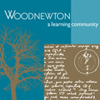

06.07.2020: Learning Project – Celebrations
Year 4
Weekly Reading Tasks | Weekly Spelling Tasks
Monday - Ask your child to read their old birthday cards and/or celebrations cards. Which messages are meaningful? Why? | Monday- Practise spelling words with the suffix ‘ly’
Tuesday – Watch Newsround and discuss what is happening in the wider world. How does your child feel about this? | Tuesday - Practise Year 3 & 4 Common Exception words by writing them on bunting one flag for one for each letter. Display them around your house.
Wednesday – Find a newspaper article online which is about some form of celebration. Use the five ‘w’’ to record why they are celebrating. | Wednesday – Create your own word search using some words which relate to celebrations
Thursday –Ask your child to listen to the poem ‘ My Friend Elsie ’. Can they identify all of the rhyming words and then add their own? | Thursday- Practise spelling words with the suffix ‘ation’
Friday - Encourage your child to read for enjoyment. See here or here for a new book. Can your child design an alternative book cover for their chosen book? | Friday – Continue to practise any words that you are unsure of from the Year 3 & 4 Common Exception words list
Weekly Writing Tasks | Weekly Maths Tasks
Monday- Be a party planner. Plan a birthday celebration party for someone in your family. Write a list of everything you will need. Think about decorations, food, invitations, games and any other items you will need. | Monday- Make a pretend menu or use the one here. Give your child scenarios linked to the menu such as, ‘You have £3.00 to spend, what different combination of items could you buy? Would you have change?’.  Or, ‘If you had £5 to spend and bought a drink and a sandwich how much change would you have?’.
Tuesday- Write an invitation for a party. Decorate the invitation with pictures or a colourful border. | Tuesday- Shopping game. Finding the coins to pay exact amounts of giving change from up to £10.00
Wednesday- Write a menu for a birthday dinner or buffet - pizza, chicken nuggets, jacket potatoes etc | Wednesday- Use the interactive teaching clock to practise reading the time on analogue and digital clocks.
Thursday- Create a design for a celebration cake. What ingredients will you use to make it? Write a recipe and a list of instructions for how to make the cake. | Thursday- Use Daily ten or Hit the Button -to practise your mental maths skills and times tables.
Friday - Can you write about how we might celebrate things in the future. Think about why we will be celebrating and what rituals might take place. You could give your celebration a special name. | Friday- Play this game to read time to the nearest 5 minutes.

Learning Project - to be done throughout the week
This project this week aims to provide opportunities for your child to learn more about celebrations. Learning may focus and different types of celebrations that take place and who may celebrate them. It could look at how people celebrate different events differently in other parts of the world.

● Country Celebrations - How are birthdays celebrated around the world? Look at this website to find out information on the celebrations.
Maybe there's a particular country your child would like to find out about. Create fact files to show the similarities and differences between the celebrations.

● Party Game Fun- Why not ask your child to plan their ideal birthday party or celebration event? Who is going to be invited to the event? What food would they like to eat? How will the room be decorated? What entertainment will there be? Play some party games as a family e.g. Musical Statues, Pin the Tail on the Donkey, etc.

● Cherished Memories- Look through old photos of previous celebrations the family have taken part in. What can your child remember about the event? Discuss why the family celebrates in this way. Do you have any family traditions? Ask your child to draw a detailed sketch of their favourite photograph from the day, if there aren’t any photographs they could do this from memory. Following this, ask your child to write a recount about the day. This could be done in the style of a diary entry or a newspaper report.

● Patron Saints and Saint Days - There are four patron saints in the UK: St. George for England, St. Andrew for Scotland, St. Patrick for Northern Ireland, and St. David for Wales. Can your child find out about each saint and why they are still celebrated in the UK? Look here for some help. Perhaps they could create a timeline of each saint’s life? Or write short information reports on each saint?

Wellbeing & P.S.H.E.
- Brain break breathing
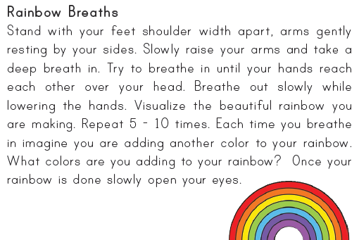

- Leave three happy notes for someone else to find in your house.
- Write a blog about something you enjoy doing. Maybe you have a favourite hobby you can write about? How does it make you feel when you are doing this activity?

- Cosmic Kids Yoga - Disco Underwater party

STEM Learning Opportunities #sciencefromhome
- Design and make a pop-up card for someone’s birthday/celebration coming up.

Additional learning resources parents may wish to engage with
- BBC Bitesize - Lots of videos and learning opportunities for all subjects.
- Classroom Secrets Learning Packs - Reading, writing and maths activities for different ages.
- Twinkl - Click on the link and sign up using your email address and creating a password. Use the offer code UKTWINKLHELPS.
- White Rose Maths online maths lessons. Watch a lesson video and complete the worksheet (can be downloaded and completed digitally).
- Times Table Rockstars and Numbots. Your child can access both of these programmes with their school logins. On Times Table Rockstars, children should aim to play Soundcheck for 20 minutes daily.
- IXL online. There are interactive games to play and guides for parents.
- P.E. with Joe Daily P.E sessions with Joe Wicks accessed through YouTube.
- Supermovers Movements to music/raps focussing on different curriculum areas
- Youth Sports Trust Sports activities for home – connected to National School Sports Week

