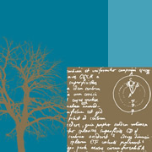
Week Commencing 6th July 2020: Famous & Significant People
Year 5
Weekly Reading Tasks | Weekly Spelling Tasks
- Can somebody who is important to your child read to them? Perhaps they could share an extract from their favourite book or a poem? | - Choose some words we have covered in our spelling lessons this year. Practise spelling them in different ways. You could write them backwards, in rainbow colours
- Encourage your child to read a newspaper article about a famous person. What can they tell about the person from the language used? Does the article criticise them or is it complimentary – how can they tell? | - Choose 5 Common Exception words here. Ask your child to write the definition of their chosen words and use them correctly in a sentence.
- Ask your child to complete the reading comprehension activity on the home learning page all about Rosa Parks. There are 3 levels of difficulty so encourage your child to challenge themselves. | - Ask your child to mind map vocabulary that they associate with the following significant people: The Queen, Guy Fawkes, Helena Lucas and Rosa Parks. They could also do this activity for other famous or significant people.
- Encourage your child to sign up to The Summer Reading Challenge to take part in the challenge. | - Can your child complete this segment puzzle (click Spelling Tiles) which focuses on words ending in: -able, -ible, -ably and -ibly?
- Character profile. Ask your child to create a profile about a famous book character e.g. Harry Potter, Matilda Wormwood or Percy Jackson. | - Pick 5 Common Exception words from the Year 5/6 spelling list here. Direct your child to represent each word as a picture.
Weekly Writing Tasks | Weekly Maths Tasks
- Create an information report about a significant/famous person of interest. Your child may choose a famous author, athlete, popstar or even a local hero such as a doctor or nurse. Include: birthplace, what they’re most famous for, significant events/achievements and any other interesting facts. | - You are going to practise your basic number skills by playing darts, which is a game that requires good mental skills.  Please see the attached sheet on Dartboard Scores.  - This time you are going to work out who has the best shot in Woodnewton  Please see the attached sheet on Top Darts.  - Make up your own Carroll Diagram with different numbers and different requirements  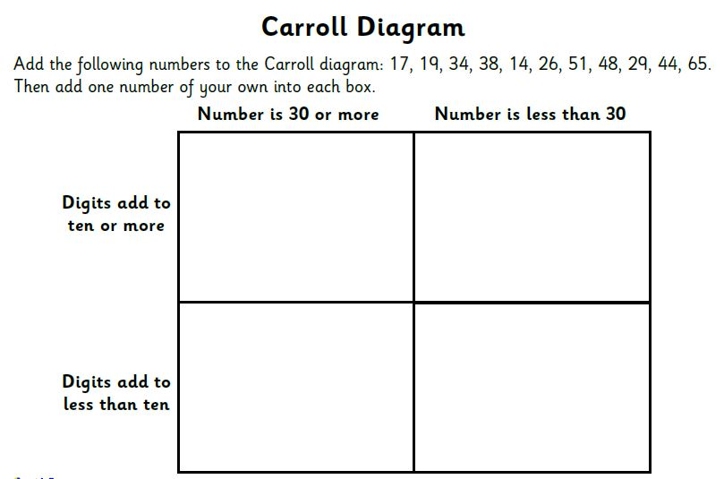  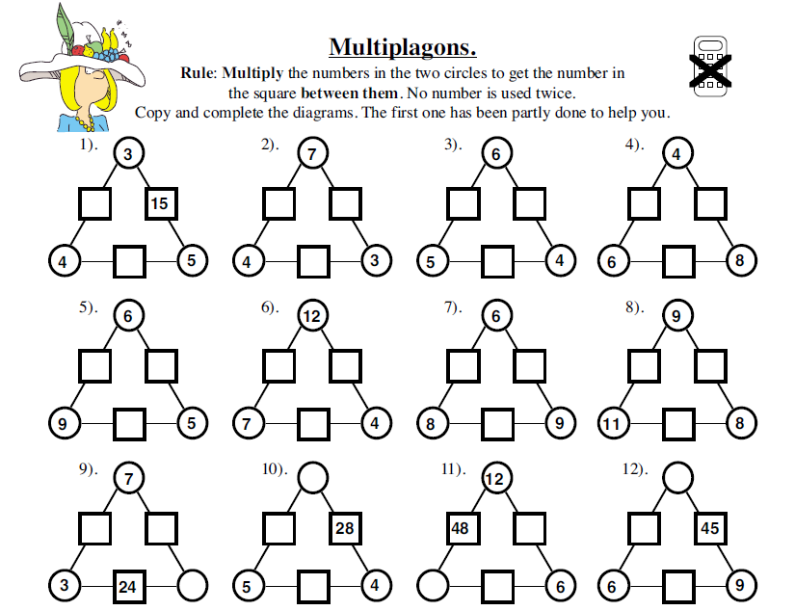  Make up your own puzzle with different numbers on the diagram  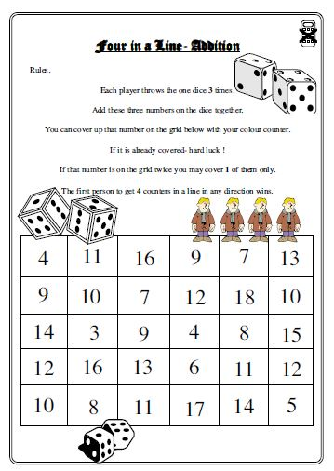
- Using the words FAMOUS PEOPLE, get your child to write an acrostic poem about significant British people in history.
- Listen to Martin Luther King’s speech I Have a Dream. Ask your child to write their own speech about their dreams. Encourage them to use the same techniques such as repetition, personification and powerful verbs.
- The wages of celebrities such as footballers and pop stars should have a maximum limit set. Encourage your child to consider the above statement. Do they think the wages of footballers and other celebrities are justified, or should there be a limit on how much they can earn? If they do feel the wages should be capped, what would they suggest the extra money be used for.
- Story writing – Encourage your child to research Anne Frank and some of her experiences as a Jew, trying to remain hidden from the Nazis. Ask your child to write a short story from Anne’s point of view. Remind them to think about the FANTASTIC’s (Feelings, Asking, Noticing, Touching, Action, Smelling, Tasting, Imagining and Checking) and to incorporate some of the grammar features taught this year, such a relative clauses, modal verbs and powerful, descriptive language.

Learning Project - to be done throughout the week
The project this week aims to provide opportunities for your child to learn more about famous or significant people. Learning may focus on past or present inventors, explorers or scientists and how they influence society today.

- Famous Brits- Lots of significant people in history have been British. Emmeline Pankhurst, Guy Fawkes and Mary Anning are just a few. Ask your child to research one of these or another famous Brit of their choice. They could create a fact file, a presentation, a chronological report of their life or present their research in any way they like.

- The Queen’s Speech - The Queen spoke to the nation on Sunday 5th April from Windsor Castle. She had an important speech to deliver where she wanted to thank people for what they were doing and to give hope that things would eventually return to normal. Ask your child to think about what they would say if they had to speak to the nation? What messages of hope would they want to give to their friends and family? Your child could write their speech or record themselves delivering their speech.

- Inspiration for Inventors- These inventors talk about where they found the inspiration for their inventions. Ask your child what problems they incur in their daily life? What inventions would make their life easier? How could they turn their idea into a product? Direct your child to mind map ideas of how they could solve their problem before designing and annotating a product. Your child may even want to make a prototype or test parts of their design to see if it would work.

- Significant to Me- Discuss with your child a person who is significant to them. This could be a famous person who has inspired them or someone who has made a positive impact on them from their everyday life. Ask them to discuss the attributes that this person has - why are they inspiring? You could share someone who is significant to you with your child as well and talk about how they have influenced you. They may wish to draw a portrait of this person.

- What it Takes- Ask your child to watch this interview with Paralympic gold medallist Helena Lucas. In this interview it talks about the dedication needed to be a successful sportsperson. Direct your child to set themselves a goal to work on every day. They could create a poster outlining their goal and the steps they will take each day to work towards it. They may want to include steps they will take when they return to school.
Mental Health and Well-being Activities
- Origami Frog – Follow the tutorial to make you own jumping origami frog. There are lots of other origami animals that you could have a go at making too.
- Gratitude Jar - Think about all the things that you are thankful for. You could either draw the outline of a jar and write the things you are thankful for inside, or you could draw pictures and put them inside a clean, empty jar. Take them out when you are feeling worried or anxious to remind you of positive things.
- Scavenger hunt – Use the scavenger hunt list on the home learning page to find things that bring you joy. These might be useful to incorporate into your transition project next week.
- Camouflage hand - Create an optical illusion of your hand to make it disappear on the page. Draw round your hand on a piece of paper. Draw horizontal lines across the drawing but make sure the lines inside your hand outline are curved slightly, while keeping the lines straight on the outside.

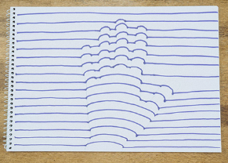
STEM Learning Opportunities #sciencefromhome
Sophia Barnacle
- Sophia was a British inventor who invented the Helter-skelter in 1907. Try using junk box material to make your own helter-skelter or marble run.
- Try and make a run that takes exactly 60 seconds for the marble to complete the run.
- To find out more about building your own marble run click here.
Additional learning resources parents may wish to engage with
- BBC Bitesize - Lots of videos and learning opportunities for all subjects.
- Classroom Secrets Learning Packs - Reading, writing and maths activities for different ages.
- Twinkl - Click on the link and sign up using your email address and creating a password. Use the offer code UKTWINKLHELPS.
- White Rose Maths online maths lessons. Watch a lesson video and complete the worksheet (can be downloaded and completed digitally).
- Times Table Rockstars and Numbots. Your child can access both of these programmes with their school logins. On Times Table Rockstars, children should aim to play Soundcheck for 20 minutes daily.
The Learning Projects are based on the National Curriculum expectations for the key stage which your child is in. It may be that your child finds the tasks set within the Learning Project for their year group too simple. If this is the case, then we suggest that your child accesses the Learning Projects which are set for the key stage above. Equally, if the projects are too challenging, then we advise that your child accesses the projects for the key stage below.
If your child requires more of a challenge, or you believe that there are some gaps in their learning then Century Tech is a fantastic resource that is currently free for home learning. The app is designed to address gaps and misconceptions, provide challenge and enables children to retain new knowledge. It uses artificial intelligence to tailor the learning to your child’s needs. Sign up here.
#TheLearningProjects

