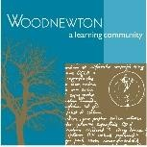

Woodnewton – A learning community

Mathematics Policy

September 2022 to 2023

At Woodnewton, we are driven by our pursuit of excellence every day. We have high expectations of learning, behaviour and respect for every member of our community. We create independent, articulate thinkers and learners who have confidence in, not only their individual ambitions, but also those of the academy as a whole. We have collaboration at the heart of everything we do and our vision is to nurture exciting, innovative, outstanding teaching and learning, embracing change and providing a world-class education for all.

Version:  V1 | Filename:  Woodnewton Mathematics Policy
Approval: Curriculum  24^{h} September 2021 | Next Review on or before:  30th September 2023
Owner:  Woodnewton | Union Status:  Not applicable

Woodnewton Mathematics Offer and Core Values
At Woodnewton, we expect all children to be exposed to Fluency, Deepening and Connections to develop as mathematicians. To nurture a love of maths, we understand that each child is unique and the quality of maths provision is tailored to meet their individual needs. Through effective quality first teaching and a bespoke approach taken by our teaching staff, our aim is to raise the attainment of all groups of children and to foster an enjoyment of maths in every child.

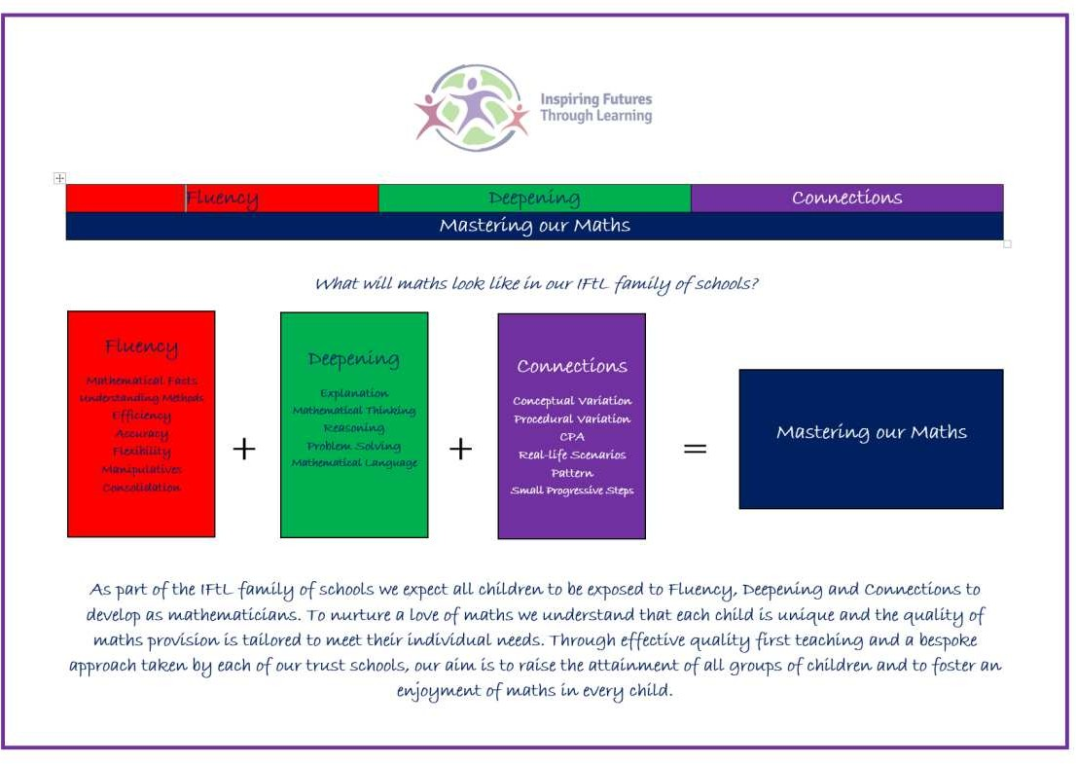
Core Values
Our school believes in the IFtL trust core values which permeate all we do. The core values of our trust, upon which our schools have based their curriculum, are as follows:
- Fun – We value the importance of providing a creative, practical and enjoyable mathematics curriculum, which generates an interest in learning. (Exploring the beauty, awe and wonder of the world through a wide range of experiences and opportunities.)

- Unique - We value the way in which all children are unique, and our mathematics curriculum supports all to achieve through a bespoke approach in each trust school. (Nurturing and supporting us all to be self-assured and promote our emotional, mental and physical well-being.)

- Together - We value how collaborative work supports pupils in developing respect for the opinions and work of others. (Embracing a love of mathematical learning.)

- Unafraid – We value our mathematics approach to encourage the development of a confident, independent and positive attitude towards mathematics. (Self-belief to achieve their dreams and aspirations.)

- Energetic – We value optimism and ensure our curriculum fully-prepares our pupils for readiness to be life-long and successful learners. (Purposeful, enriching experiences and opportunities within an inspiring and engaging curriculum, underpinned by core skills and knowledge which enables pupils to develop and discover their interests and talents.)

- Responsible – we value how the children will develop mathematical skills necessary for life and an awareness of the uses of mathematics in the world outside the classroom. (Creating independent and resilient learners who are equipped with the skills to contribute to an ever-changing world and are fully prepared for future success in their next steps.)

- Strong - We value how our curriculum in every school will promote the power of mathematics when communicating and explaining and provide opportunities to develop the resilience of our learners. (Confident and articulate individuals who use and understand a wide and rich vocabulary)

Mathematical Priorities and Intent:

Implementation – Our curriculum offer and policy incorporates and promotes the IFTL core values and principles highlighted.

The Curriculum Impact, including mathematics ensures that, through our curriculum, we aim to enable children to become:

High achievers & successful learners who have a passion for learning, make progress and achieve
- Have essential skills of English, maths, communication and technology;
- Enjoy and are motivated and determined to reach their full potential, now and in the future;
- Are open to new thinking and ideas;
- Able to learn independently and collaboratively, as part of a team;
- Communicate effectively in a variety of ways;
- Have enquiring minds and think for themselves to process information, reason, question and evaluate;
- Are creative, innovative and resourceful, able to identify and solve problems in ways that draw upon a range of learning areas;
- Know about big ideas and events that shape our world.

Confident individuals who are equipped with the skills to contribute to an ever-changing world
- Have a sense of self-worth, self-awareness and personal identity that enables them to manage their emotional, mental, spiritual and physical wellbeing;
- Relate well to others and maintain good relationships;
- Become increasingly independent and are able to take the initiative;
- Make healthy lifestyle choices;
- Take managed risks and stay safe;
- Are willing to try new things and make the most of opportunities;
- Have a sense of optimism about their lives and the future;
- Develop personal values and attributes such as honesty, empathy and respect for others.

Responsible citizens who make a positive contribution to society
- Are prepared for their role as a family member, in their community and life in modern Britain;
- Have secure values and beliefs and have principles to distinguish right from wrong;
- Understand their own and others’ cultures and traditions within British Heritage, and have a strong sense of their own place in the world;
- Co-operate with others;
- Respect others and act with integrity;
- Appreciate diversity;
- Sustain and improve the environment, locally and globally.

We are committed to ensuring all our children are:

Ready for learning at each stage of their education and beyond
- Embrace learning and achieving the very best they can be;
- Are fully and well prepared for the next stage in their school journey;
- Understand their own and others contributions to ensure they are best prepared for all aspects of their learning and journey throughout their education;
- Take ownership of their own learning and development;
- Understand what helps them learn and what prevents them developing strategies to overcome barriers.

Purposeful learning experiences provided and embraced throughout all areas of the school curriculum
- Positively respond to high expectations and opportunities provided them;
- Celebrate the unique school and local communities;
- Embrace purposeful learning that challenges and fulfils every individual;
- Are reflective learners who aspire to improve and develop, learning from mistakes;
- Are nurtured, challenged and inspired to achieve their full potential.

Engaged Individuals who are persistent, persevere, creative and are dynamic
- Have a determination to learn and overcome obstacles;

- Embrace challenge and the learning opportunities offered them;
- Aspire to be the best they can be;
- Mutually respect and trust themselves sand others;
- Collaboratively pursue excellence;
- Actively involve and immerse themselves in school and community life;
- Celebrate uniqueness and being part of one school and Trust family;
- Are intrinsically motivated to be the best they can be.

Progression of skills
The mathematics curriculum at Woodnewton has been carefully planned so that lessons build sequentially through the culmination of both knowledge and skills. Care and attention must be paid to identify not only the next step for a child, but where they have come from in their learning journey so far. Teaching staff must always be aware of the mathematical skills required to develop both factual & procedural fluency and conceptual understanding. Without a clear knowledge of the prerequisite skill, there are likely to be significant challenges.

Assessing Pupil Progress
It is essential that teachers regularly monitor pupil progress so that gaps in knowledge can be identified, planned for and targeted in further lessons. Moreover, having a clear knowledge of the impact that each lesson has had allows teaching staff to put in place further intervention for those who may need it. Teaching mathematics with a mastery approach means that lessons must follow a carefully planned sequence and, if there are gaps identified in an individual’s understanding, support must be put in place so that the child(ren) is able to access future learning without falling further behind their peers. We will balance formative and summative assessment, using O-Track and Cornerstones testing, throughout the academic year to build a secure understanding of the needs of all children. Furthermore, we will complete the following national summative assessments; end of key stage assessments (SATs), the reception baseline assessment (replacing Year 2 SATs from 2022/23) and the multiplication tables check in Year 4.
Response to COVID – 19

Due to the partial closure of schools in the Summer term 2020, schools have been asked by the Government to design a recovery curriculum to ensure children make rapid progress throughout the academic year. At Woodnewton, we have devised a mathematics recovery curriculum taking into account the new DfE guidance. The guidance outlines the priority areas and concepts for each year group so that pupils can progress through Primary school and beyond. It is expected that schools will swiftly assess their pupils in September 2020 to quickly identify the gaps in children’s fluency and core number skills and decide how best to address these.

The Quality of Education

Teachers reinforce an expectation that all pupils are capable of achieving high standards in mathematics. The expectation is that the large majority of pupils’ progress through the curriculum content at the same pace. However, decisions about when to progress will always be based on the security of pupils’ understanding and their readiness to progress to the next stage. Differentiation is achieved by emphasising deep knowledge and through targeted support and intervention. Pupils who grasp concepts rapidly will be challenged through being offered rich and sophisticated problems before any acceleration through new content. Those who are not sufficiently fluent with earlier material will consolidate their understanding, including through additional practice, before moving on.

Early Years Foundation Stage

All children in the EYFS follow a broad‐based curriculum and have a wide range of opportunities to explore mathematical concepts; both planned and self‐initiated inside and outdoors. Children also take part in whole class and group activities designed to develop mathematical language and concepts. This supports development of initiative and an ability to work both independently and in cooperation with others. Resources are used imaginatively and creatively to stimulate curiosity and excitement about the world around them and to develop an understanding of mathematics through a process of enquiry and investigation.

Key Stages 1 and 2

The principal focus of mathematics teaching in Key Stages 1 and 2 is to ensure that pupils develop confidence and mental fluency.

Children will be taught mathematical knowledge, skills and understanding through:

- Direct instruction following a clear, small-step progression, building gradually on previously learning and providing appropriate challenge for all.
- Using relevant real-life examples and mathematical models and images to develop secure conceptual understanding.
- Practical activity, exploration and discussion.
- Using mathematical ideas in practical activities then recording these using objects, pictures, diagrams, words, numerals and symbols.
- Quality questioning and supported discussion to probe understanding and remedy their misconceptions. They will be supported in making their thinking clear to themselves as well as others when discussing their mathematics.

- Carefully designed variation within this builds fluency and understanding of underlying mathematical concepts in tandem.
- Using a robust assessment system that tailors interventions and planning to support all learners to progress.

Core Pedagogy
At Woodnewton, we are committed to ensuring our schools provide a broad, balanced, rich and vibrant curriculum including all aspects of mathematics, to excite and motivate our children, enabling them to develop confidence in themselves as independent, enthusiastic life-long mathematical learners. We believe that children respond best when they enjoy ownership of their learning, when learning experiences are connected, relevant and achieved through practical, purposeful, active learning every day. We understand that ensuring mathematical vocabulary, skills, knowledge and understanding is committed to long term memory and meta-cognition skills are fundamental to creating longer term successful learners; opportunities for these will be embedded throughout the mathematical and wider curriculum.

Curriculum Coverage

At Woodnewton, we use mastery resources from the NCETM and White Rose Maths Hub to plan a mathematics curriculum offer of the highest quality with suitable coverage. Furthermore, we use the ‘Ready to Progress’ criteria published by the DFE, in partnership with the NCETM, to ensure our curriculum sequentially and cumulatively develops strong pupil knowledge, understanding and skills with progression occurring throughout the year and across the years within the school. https://assets.publishing.service.gov.uk/government/uploads/system/uploads/attachment_ data/file/897806/Maths_guidance_KS_1_and_2.pdf

Our teachers ensure their mathematical curriculum plans to eliminates gaps, and should they occur or be in place on entry, they are swiftly identified and timely interventions will occur to close them. We ensure all teaching staff are provided with effective CPD and support to ensure they have good subject knowledge for all areas within mathematics they teach and that all provide a quality education; to ensure effective delivery, check pupil understanding systematically and quickly adapt their teaching to address misconceptions or misunderstandings.

Safeguarding Statement
Safeguarding is everybody’s business. At Woodnewton, we are committed to ensuring that all our children and young people are safe and feel safe. The right to be safe for any member of the Woodnewton community is a non-negotiable and paramount. Safeguarding and child protection is crucial and we are fully committed to ensuring the welfare and safety of all our children and staff. We must fully adhere to all safeguarding and child protection legislation, policy and procedures at all times and under any circumstances.

Teaching Mathematics for Mastery at Woodnewton – a learning community

What do we mean by mastery?

The essential idea behind mastery is that all children need a deep understanding of the mathematics they are learning so that:

- Future mathematical learning is built on solid foundations which do not need to be re-taught.
- There is no need for separate catch-up programmes due to some children falling behind
- Children, who, under other teaching approaches, can often fall a long way behind, are better able to keep up with their peers, so that gaps in attainment are narrowed whilst the attainment of all is raised.
- Children who grasp key concepts rapidly are challenged to deepen their mathematical understanding.

There are generally four ways in which the term mastery is used in regards to raising standards in mathematics:

- A mastery approach: a set of principles and beliefs. This includes a belief that all pupils are capable of understanding and doing mathematics, given sufficient time. Pupils are neither ‘born with the maths gene’ nor ‘just no good at maths’. With good teaching, appropriate resources, effort and a ‘can do’ attitude all children can achieve and enjoy mathematics.

- A mastery curriculum: one set of mathematical concepts and big ideas for all. All pupils need access to these concepts and ideas and to the rich connections between them. There is no such thing as ‘special needs mathematics’ or ‘gifted and talented mathematics’. Mathematics is mathematics and the key ideas and building blocks are important for everyone.

- Teaching for mastery: a set of pedagogic practices that keep the class working together on the same topic, whilst at the same time addressing the need for all pupils to master the curriculum and for some to gain greater depth of proficiency and understanding. Challenge is provided by going deeper rather than accelerating into new mathematical content. Teaching is focused, rigorous and thorough, to ensure that learning is sufficiently embedded and sustainable over time. Long term gaps in learning are prevented through speedy teacher intervention. More time is spent on teaching topics to allow for the development of depth and sufficient practice to embed learning. Carefully crafted lesson design provides a scaffolded, conceptual journey through the mathematics, engaging pupils in reasoning and the development of mathematical thinking.

- Achieving mastery of particular topics and areas of mathematics. Mastery is not just being able to memorise key facts and procedures and answer test questions accurately and quickly. It involves knowing ‘why’ as well as knowing ‘that’ and knowing ‘how’. It means being able to use one’s knowledge appropriately, flexibly and creatively and to apply it in new and unfamiliar situations.

What is teaching for mastery?
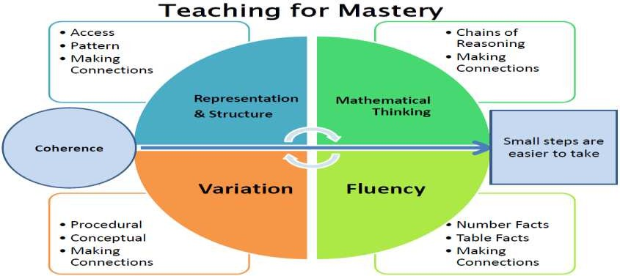
Since mastery is what we want pupils to acquire (or go on acquiring), rather than teachers to demonstrate, we use the phrase ‘teaching for mastery’ to describe the range of elements of classroom practice and school organisation that combine to give pupils the best chances of mastering mathematics.

Mastering maths means acquiring a deep, long-term, secure and adaptable understanding of the subject. At any one point in a pupil’s journey through school, achieving mastery is taken to mean acquiring a solid enough understanding of the maths that’s been taught to enable him/her move on to more advanced material.

Our approach is based on key principles:

Problem solving

Mathematical problem-solving is at the heart of our approach. Pupils are encouraged to identify, understand and apply relevant mathematical principles and make connections between different ideas. This builds the skills needed to tackle new problems, rather than simply repeating routines without grasping the principles.

High expectations

We believe no child should be left behind. We focus on pupils ‘keeping up over catching up’. By making high expectations clear – and emphasising the high value of mathematics education – learners are encouraged to build confidence and resilience.

Concrete, pictorial, abstract

Objects, pictures, words, numbers and symbols are everywhere. Our approach incorporates all of these to help pupils explore and demonstrate mathematical ideas, enrich their learning experience and deepen understanding. Together, these elements help cement knowledge so pupils truly understand what they’ve learnt.

Depth before breadth

All learners benefit from deepening their conceptual understanding of mathematics, regardless of whether they've previously struggled or excelled. We believe pupils must be given time to fully understand, explore and apply ideas - rather than accelerate through new topics. This approach enables learners to truly grasp a concept, and the challenge comes from investigating it in new, alternative and more complex ways.

Growth mindset

We believe our ‘abilities’ are neither fixed nor innate, but can be developed through practice, support, dedication and hard work. ‘Natural talent’ is just a starting point and does not determine who has more or

less potential to achieve. This belief encourages a love of learning and resilience that enables everyone to achieve.

Mathematical language

The way pupils speak and write about mathematics transforms their learning. We use a carefully sequenced, structured approach to introduce and reinforce mathematical vocabulary. We always ask pupils to explain the mathematics in full sentences (not just what the answer is, but how they know it’s the right answer). This is key to building mathematical language and reasoning skills.

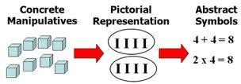

What will I see in mathematics lessons at Woodnewton?

At Woodnewton – a learning community, we teach mathematics for mastery, an engaging and accessible style of mathematics teaching, inspired by Singapore and Shanghai. Our approach enhances mathematical understanding, enjoyment and achievement for every child.

Children are encouraged to physically represent mathematical concepts. Objects and pictures are used to demonstrate and visualise abstract ideas, alongside numbers and symbols.

Mathematical concepts are explored in a variety of representations and problem-solving contexts to give pupils a richer and deeper learning experience.
Whole class together – we teach mathematics to whole classes and do not label children. Lessons are planned based on formative assessment of what pupils already know and we include all children in learning mathematical concepts. At the planning stage, teachers consider the scaffolding that may be required for children struggling to grasp concepts in the lesson and suitable challenge questions for those who may grasp the concepts rapidly.

Longer but deeper – in order to ensure children have a secure and deep understanding of the content taught, our plans have been adjusted to allow longer on topics and we move more slowly through the curriculum. Lessons are planned in accordance with the White Rose Maths Hub curriculum overview to ensure purposeful, curriculum coverage. Teachers adapt each lesson to meet the needs of their children and carefully construct questioning / tasks which will allow children to learn the content more deeply. The learning will focus on one key conceptual idea and connections are made across mathematical topics.
Children will be given time to ‘master’ concepts but lessons will be appropriately paced to develop learning
and enable children to be active.

Key learning points are identified during planning and a clear journey through the maths developed.

Questions will probe pupil understanding throughout and responses are expected in full sentences, using precise mathematical vocabulary.

Fluency – there is a whole school focus on developing an instant recall of key facts, such as number bonds, times tables and unit + unit addition facts. Each year group has daily sessions in addition to the 5 (1 hour) timetabled maths lessons and lessons begin with a fluency challenge.

Move between the concrete and the abstract
Children’s conceptual understanding and fluency is strengthened if they experience concrete, visual and
abstract representations of a concept during a lesson. Moving between the concrete and the abstract helps

children to connect abstract symbols with familiar contexts, thus providing the opportunity to make sense of, and develop fluency in the use of, abstract symbols.

For example, in a lesson about number bonds, children could be asked to draw a picture to represent the sum, create physical patterns through the use of various manipulative resources, or in a subsequent lesson, they could be asked to discuss the similarities and differences of three visual representations of the same question:
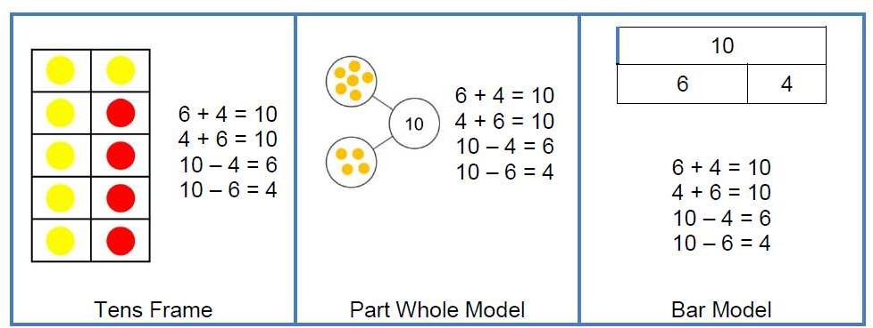

Lesson Structure

Exploration – instead of ‘Let me teach you…’ or giving a learning objective as a starting point, children are
encouraged to explore a problem themselves to see what they already know.

Develop reasoning and deep understanding (contexts and representations of mathematics) – problems are often set in real life contexts – carefully chosen practical resources and pictorial representations are used to explore concepts. These pictorial representations will appear in books as children show their understanding, rather than answers to a series of calculations. The use of practical resources, pictorial representations and recording takes place in every lesson (the CPA approach).

Structuring – the teacher will organise the findings of the exploration, compare/contrast strategies and guide toward the most efficient strategy (or the one being learnt that day).

Step by step approach – journey through the mathematics through small carefully crafted steps to support deep understanding.

Questions to challenge thinking – teachers use questioning throughout every lesson to check understanding – a variety of questions are used, but you will hear the same ones being repeated: How do you know? Can you prove it? Are you sure? Can you represent it another way? What’s the
value? What’s the same/different about? Can you explain that? What does your partner think? Can you imagine?

Discussion and feedback – pupils have opportunities to talk to their partners and explain/clarify their thinking. There will be more talking and work on whiteboards prior to recording in books. We do not want children to attempt independent recording until we believe they are secure with the concept. Feedback will be given to children regularly and time set aside for them to respond.

Marking in books It is important for teachers to distinguish between a pupil’s simple slip and an error that reflects a lack of understanding: For slips, it is often enough to simply indicate where each slip occurs and encourage pupils to correct them. At WOODNEWTON, these will be indicated with a purple highlighter. If errors demonstrate lack of understanding, the teacher may decide to take alternative courses of action. For instance, with a small number of pupils, the teacher may arrange same-day intervention while for a large number of pupils, the errors will be addressed in the next lesson. Evidence shows (Black and Wiliam 1998) that pupils benefit from marking their own work. Part of this responsibility is to identify for themselves the facts, strategies and concepts they know well and those which they find harder and need to continue to work on. However, it is essential for the teacher to check this through but extensive written comments are

not required and are down to the individual teacher’s discretion. At WOODNEWTON, correct answers can simply be highlighted in green.

Practising – not drill and practice but “intelligent practice” characterised by variation

Rapid intervention new learning is built upon previous understanding, so in order for learning to progress and to keep the class together pupils need to be supported to keep up and areas of difficulty must be dealt with as and when they occur. We do this through supporting children as soon as we see the need for additional intervention. In addition, we still run intervention sessions outside of the maths lesson for some targeted children.

SEN pupils – may be supported by additional adults, different resources, differentiated activities. They may also complete additional activities outside of the mathematics lesson. We do not label our
children. We have high expectations of all children and strongly believe that all children are equally able in mathematics. Some may take longer to grasp concepts and may need careful scaffolding or extra time/support (guided groups, same day catch-up, additional homework, pre-teaching, intervention group, specific parent support).

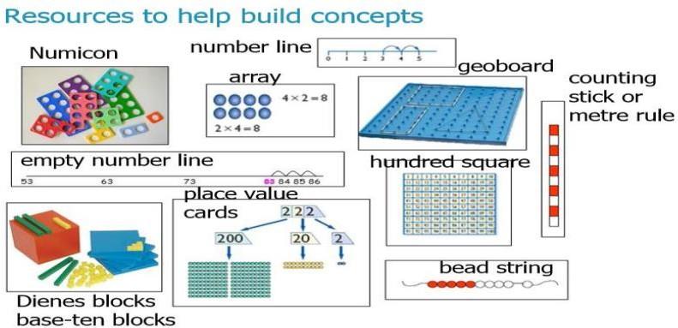

Key Documents

IFTL Calculation policy NCETM Calculation guidance

Teaching for mastery – Maths Hub
Developing mastery in mathematical fluency – Maths Hub Debbie Morgan – Teaching for mastery NCETM

Ready to progress criteria - DFE

Mastery!

A pupil really understands a mathematical concept, idea or technique if he or she can:
- describe it in his or her own words; (prompts for chn could be: I noticed that…I think that…I wonder if…)
- represent it in a variety of ways (e.g. using concrete materials, pictures and symbols – the CPA approach)¹;
- explain it to someone else; (are they able to explain the mathematics to one of the children who have not yet understood, so that they understand?)
- make up his or her own examples (and non-examples) of it;
- see connections between it and other facts or ideas;
- recognise it in new situations and contexts;
- make use of it in various ways, including in new situations.

Examples of challenge on planning could show:
- Find another way/use a different way of solving the problem
- Write a story about what you have done
- Write a note to a teacher and explain what we have been doing in our maths lesson today

Quick 6 activities:
- Create a word problem to match today’s learning.
- Write an explanation of your preferred method with words and pictures.
- Write an explanation of a method which you did not choose.
- Develop a new method for solving the problem.
- Show a physical model of the problem.

- Show a visual model of the problem.

Depth 5:
- D o you agree? (true/false, etc)
- E xplict use of misconceptions and mistakes
- P robing questions (show me, convince me, what's the same, what's different?, etc)
- T he missing digit/number (empty box)
- H ere's the answer, create the question

